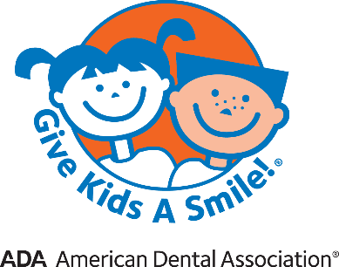
“Give Kids A Smile!”
Limited Doctor/Patient Relationship

I, _______________________________, recognize that Dr. _________________________ is treating/ examining my child today during the “Give Kids A Smile!” Day at my request. I realize that my child’s relationship with the dentist is limited to my child’s visit today. I understand that Dr. _________________________ is not my child’s dentist, and that my child is not his/her patient.
I acknowledge that the dentist owes my child no duty to treat any condition my child may have.
I understand that, if the dentist recommends need for further treatment for my child, it is my responsibility to make/keep that appointment and be sure that my child received further care.

Patient Name: __________________________________________
Parent or Legal Guardian Name (Print): __________________________________________
Parent or Legal Guardian Signature: __________________________________________
Witness Signature: __________________________________________
Dentist Signature: __________________________________________
Date: ________________

